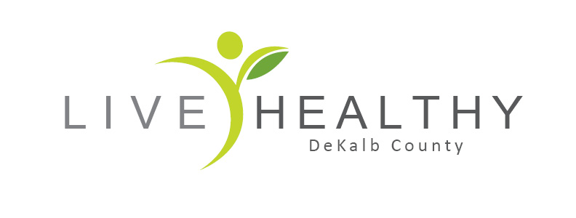 First 2020 FSC Meeting of the Year!!!!!
Dekalb County Outreach Building Blank Slate Room: 2550 N Annie Glidden Rd, DeKalb, IL 60115
(We will talk about changing the monthly meeting times to the second Thursday of the month at 1pm) – Please email me your thoughts if you do not come to the meeting!!! thank you

- Summary and updates from the December FSC Summer Food Summit

- Summer Hunger in DeKalb County- Grant opportunity!!!!! Ideas and input from the group

- My Pantry Express Program Volunteer recruitment ideas?

