Default Report
Bridges Out of Poverty Survey
April 9th 2018, 4:20 pm MDT
Q2 - Do you agree that Americans from a low socioeconomic status have access to modern amenities such as air conditioning, computers, smartphones, and flat screen TVs?
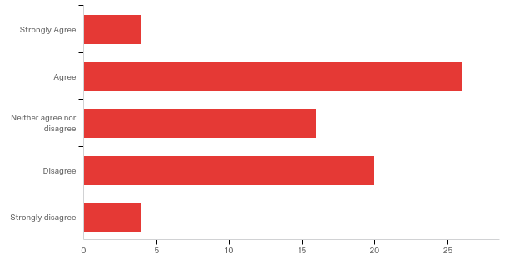

# | Answer | % | Count
1 | Strongly Agree | 5.71% | 4
2 | Agree | 37.14% | 26
3 | Neither agree nor disagree | 22.86% | 16
4 | Disagree | 28.57% | 20
5 | Strongly disagree | 5.71% | 4
 | Total | 100% | 70

Q3 - Do you agree that Americans from a low socioeconomic status have access to stores that provide fresh sustainable foods?
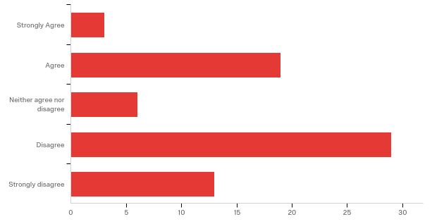

# | Answer | % | Count
1 | Strongly Agree | 4.29% | 3
2 | Agree | 27.14% | 19
3 | Neither agree nor disagree | 8.57% | 6
4 | Disagree | 41.43% | 29
5 | Strongly disagree | 18.57% | 13
 | Total | 100% | 70

Q4 - How would you rate your understanding of the difference between Situational Poverty and Generational Poverty?
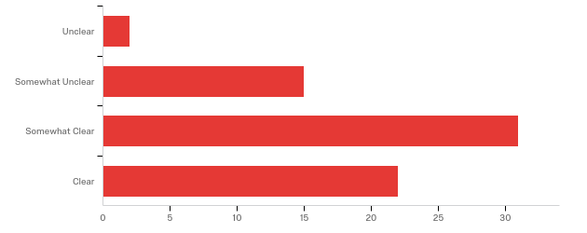

# | Answer | % | Count
1 | Unclear | 2.86% | 2
2 | Somewhat Unclear | 21.43% | 15
3 | Somewhat Clear | 44.29% | 31
4 | Clear | 31.43% | 22
 | Total | 100% | 70

Q5 - How would you rate your understanding of the barriers those born into Generational Poverty face when attempting to advance financially?
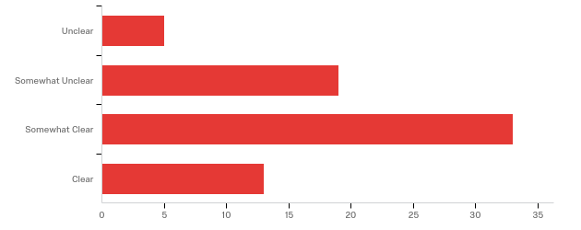

# | Answer | % | Count
1 | Unclear | 7.14% | 5
2 | Somewhat Unclear | 27.14% | 19
3 | Somewhat Clear | 47.14% | 33
4 | Clear | 18.57% | 13
 | Total | 100% | 70

Q6 - How would you rate your understanding of the ways a child raised in poverty sees the world differently than one born into a more privileged situation?
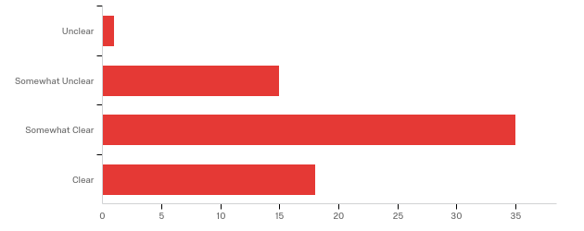

# | Answer | % | Count
1 | Unclear | 1.45% | 1
2 | Somewhat Unclear | 21.74% | 15
3 | Somewhat Clear | 50.72% | 35
4 | Clear | 26.09% | 18
 | Total | 100% | 69

Q7 - How would you rate your understanding of the tools needed to emerge from poverty and achieve financial stability?
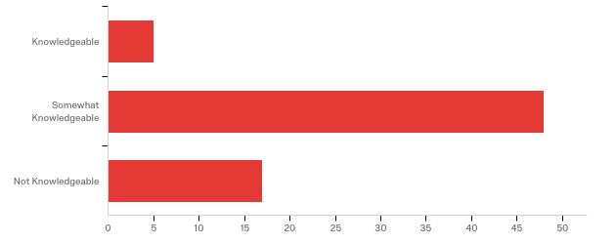

# | Answer | % | Count
1 | Knowledgeable | 7.14% | 5
2 | Somewhat Knowledgeable | 68.57% | 48
3 | Not Knowledgeable | 24.29% | 17
 | Total | 100% | 70

Q8 - Do you agree with the statement that conditions of poverty are likely to lead parents to be unengaged with their children?
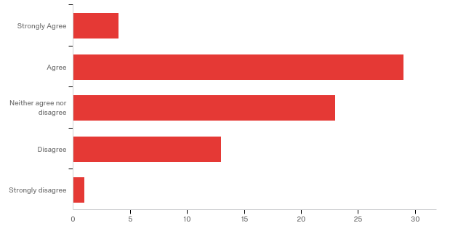

# | Answer | % | Count
1 | Strongly Agree | 5.71% | 4
2 | Agree | 41.43% | 29
3 | Neither agree nor disagree | 32.86% | 23
4 | Disagree | 18.57% | 13
5 | Strongly disagree | 1.43% | 1
 | Total | 100% | 70

Q9 - Do you agree with the statement that stressors from poverty are likely to break up family structures?
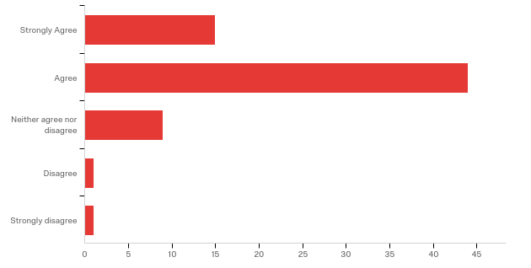

# | Answer | % | Count
1 | Strongly Agree | 21.43% | 15
2 | Agree | 62.86% | 44
3 | Neither agree nor disagree | 12.86% | 9
4 | Disagree | 1.43% | 1
5 | Strongly disagree | 1.43% | 1
 | Total | 100% | 70

Q10 - How would you rate your understanding of the stressors a family endures while in poverty?
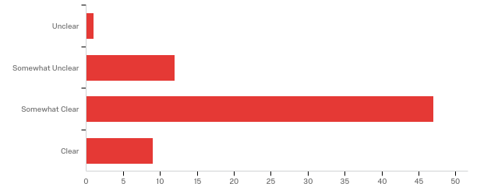

# | Answer | % | Count
1 | Unclear | 1.45% | 1
2 | Somewhat Unclear | 17.39% | 12
3 | Somewhat Clear | 68.12% | 47
4 | Clear | 13.04% | 9
 | Total | 100% | 69

Q11 - How much do you agree with the statement “There is a language barrier between children of different socioeconomic backgrounds”?
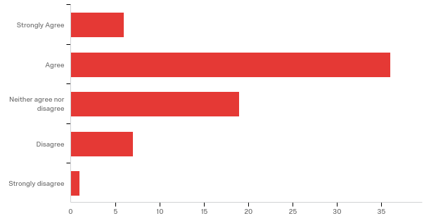

# | Answer | % | Count
1 | Strongly Agree | 8.70% | 6
2 | Agree | 52.17% | 36
3 | Neither agree nor disagree | 27.54% | 19
4 | Disagree | 10.14% | 7
5 | Strongly disagree | 1.45% | 1
 | Total | 100% | 69

Q12 - How much do you agree with the statement “Schools adequately account for differences in language comprehension and vocabulary between students when teaching language skills”?
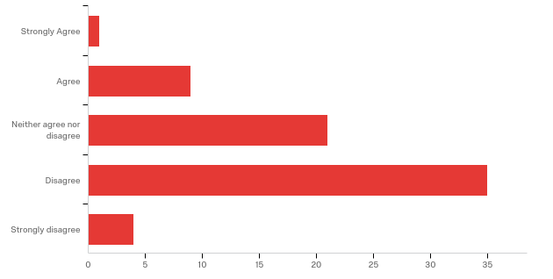

# | Answer | % | Count
1 | Strongly Agree | 1.43% | 1
2 | Agree | 12.86% | 9
3 | Neither agree nor disagree | 30.00% | 21
4 | Disagree | 50.00% | 35
5 | Strongly disagree | 5.71% | 4
 | Total | 100% | 70

Q13 - How much do you agree with the statement “People from impoverished backgrounds are less likely to learn or use formal language”?
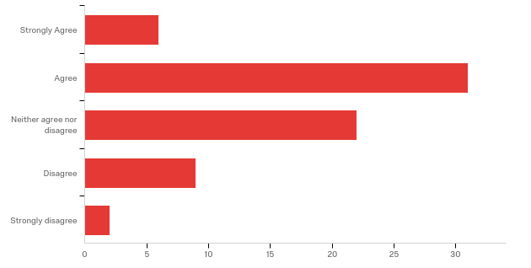

# | Answer | % | Count
1 | Strongly Agree | 8.57% | 6
2 | Agree | 44.29% | 31
3 | Neither agree nor disagree | 31.43% | 22
4 | Disagree | 12.86% | 9
5 | Strongly disagree | 2.86% | 2
 | Total | 100% | 70

Q14 - How much do you agree with the phrase “Most people routinely address others with mutual respect regardless of social status”?
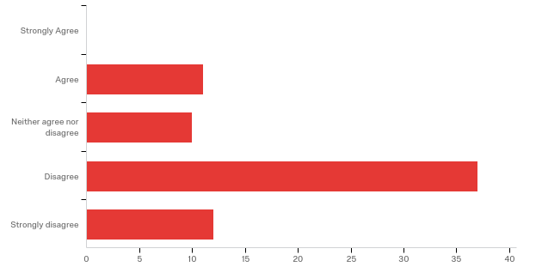

# | Answer | % | Count
1 | Strongly Agree | 0.00% | 0
2 | Agree | 15.71% | 11
3 | Neither agree nor disagree | 14.29% | 10
4 | Disagree | 52.86% | 37
5 | Strongly disagree | 17.14% | 12
 | Total | 100% | 70

Q15 - How would you rate your understanding of how poverty affects your local community?
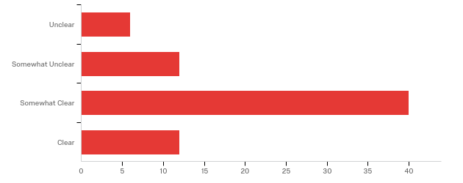

# | Answer | % | Count
1 | Unclear | 8.57% | 6
2 | Somewhat Unclear | 17.14% | 12
3 | Somewhat Clear | 57.14% | 40
4 | Clear | 17.14% | 12
 | Total | 100% | 70

Q16 - To what degree are you aware of which of your local community organizations are currently working to combat poverty?
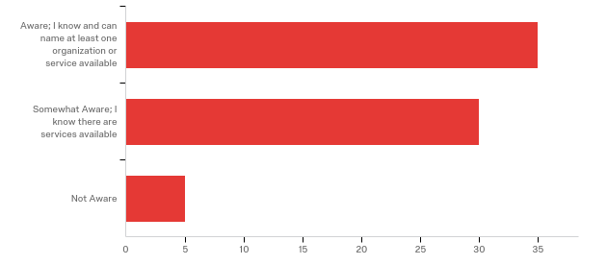

# | Answer | % | Count
1 | Aware; I know and can name at least one organization or service available | 50.00% | 35
2 | Somewhat Aware; I know there are services available | 42.86% | 30
3 | Not Aware | 7.14% | 5
 | Total | 100% | 70

Q17 - Are you currently involved in your local community (e.g. a member of a neighborhood group, community organization, faith-based group, etc.)?
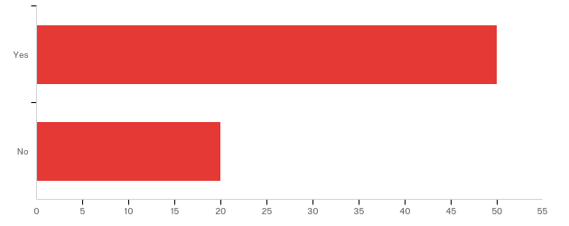

# | Answer | % | Count
1 | Yes | 71.43% | 50
2 | No | 28.57% | 20
 | Total | 100% | 70

Q18 - Rank these areas in the order that you think cause a person or family to become impoverished:1- Leading Cause 2- Second Likely Cause 3- Third Likely Cause 4- Fourth Likely Cause

# | Question | 1 |  | 2 |  | 3 |  | 4 |  | Total
1 | Behavior of Individual | 14.29% | 9 | 19.05% | 12 | 26.98% | 17 | 39.68% | 25 | 63
2 | Human and Social Capital | 19.05% | 12 | 52.38% | 33 | 20.63% | 13 | 7.94% | 5 | 63
3 | Exploitation | 1.59% | 1 | 19.05% | 12 | 39.68% | 25 | 39.68% | 25 | 63
4 | Political and Economic Structures | 65.08% | 41 | 9.52% | 6 | 12.70% | 8 | 12.70% | 8 | 63

# | Question | 1 |  | 2 |  | 3 |  | 4 |  | Total
1 | Behavior of Individual | 14.29% | 9 | 19.05% | 12 | 26.98% | 17 | 39.68% | 25 | 63
2 | Human and Social Capital | 19.05% | 12 | 52.38% | 33 | 20.63% | 13 | 7.94% | 5 | 63
3 | Exploitation | 1.59% | 1 | 19.05% | 12 | 39.68% | 25 | 39.68% | 25 | 63
4 | Political and Economic Structures | 65.08% | 41 | 9.52% | 6 | 12.70% | 8 | 12.70% | 8 | 63

Q20 - How much do you agree with this phrase, "People in poverty worry about quantity of food while those in a higher economic class tend to worry about taste or quality."
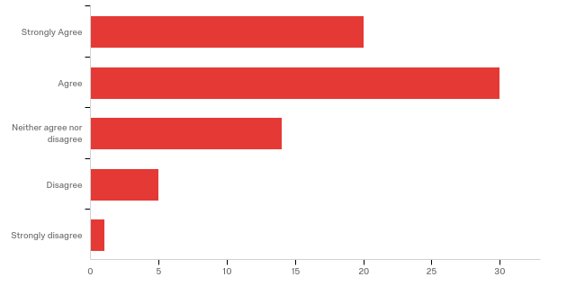

# | Answer | % | Count
1 | Strongly Agree | 28.57% | 20
2 | Agree | 42.86% | 30
3 | Neither agree nor disagree | 20.00% | 14
4 | Disagree | 7.14% | 5
5 | Strongly disagree | 1.43% | 1
 | Total | 100% | 70

Q21 - How much do you agree with this statement, "For people in poverty, money is to be spent, while others in a higher economic class view money as something to be managed."
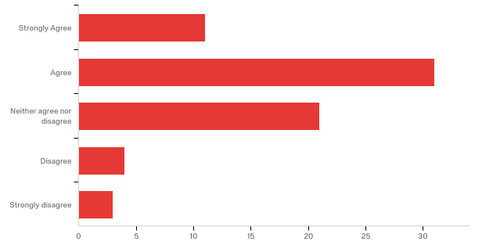

# | Answer | % | Count
1 | Strongly Agree | 15.71% | 11
2 | Agree | 44.29% | 31
3 | Neither agree nor disagree | 30.00% | 21
4 | Disagree | 5.71% | 4
5 | Strongly disagree | 4.29% | 3
 | Total | 100% | 70

Q22 - How much do you agree with this statement, "There are certain differences in norms between classes that hinder communication or interaction?
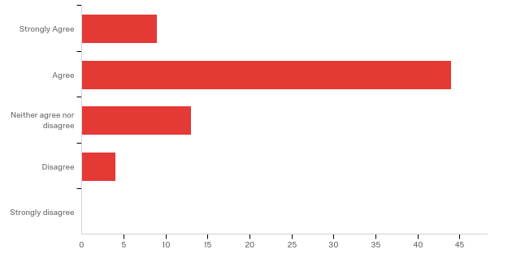

# | Answer | % | Count
1 | Strongly Agree | 12.86% | 9
2 | Agree | 62.86% | 44
3 | Neither agree nor disagree | 18.57% | 13
4 | Disagree | 5.71% | 4
5 | Strongly disagree | 0.00% | 0
 | Total | 100% | 70

